Dublin Port Maintenance Dredging
Dublin Port Company (DPC) requires regular maintenance dredging of the Port’s navigation channel, basins and berthing pockets to maintain sufficient water depth to allow the safe passage of cargo and passengers to and from the Port.
The last maintenance dredging campaign was undertaken in 2018 but since then sediment has built up over time causing a reduction in the water depth required in parts of the navigation channel, basins and berthing pockets, thereby hampering day-to-day Port operations.
Maintenance Dredging 2017 campaign
DPC intend to carry out a Maintenance Dredging campaign commencing 10th September 2020, weather permitting, in order to re-establish the water depth required within the navigation channel, basins and berths. The maintenance dredging campaign will be completed by 30th September 2020. The maintenance dredging campaign will be undertaken in accordance with the conditions as set out in Foreshore Licence FS 006893 and Dumping at Sea Permit S0004-02.
Notification has been sent to both DHPLG and EPA of DPC’s intention to undertake these essential works.
The international dredging company Boskalis has been appointed to undertake the maintenance dredging campaign using a trailer suction hopper dredger and support vessels similar to the types shown in Plates 1 &2.
Environmental Considerations
DPC’s current practice is to dispose of the dredge material at the licenced offshore disposal site located to the west of the Burford Bank in compliance with the conditions of a Dumping at Sea Permit from the EPA. The licenced offshore disposal site lies within the Rockabill to Dalkey Island candidate Special Area of Conservation (site code: 003000). The qualifying interests for the site are Harbour Porpoise and reefs. As there are no reefs near to the site, the key qualifying interest is Harbour Porpoise.
In order to safeguard the Harbour Porpoise, Dublin Port Company confirms that it shall be fully compliant with the requirements set out in National Parks & Wildlife Service’s “Guidance to Manage the risk to Marine Mammals from Man-made Sound Sources in Irish Waters” (January 2014) in respect of both the maintenance dredging activity on the foreshore and the disposal activity at the licenced offshore disposal site. As part of this commitment, an independent, suitably qualified, Marine Mammal Observer will be present during the dredging and dumping activities to ensure full compliance with the Guidance. This will ensure that the maintenance dredging will have no measureable impact on the welfare of Harbour Porpoise in Dublin Bay and the Irish Sea.
Contacting DPC
If you have any concerns, or complaints, with respect to the Maintenance Dredging Campaign 2020, direct contact can be made with DPC by phoning the following number during normal business hours
Phone 01 8876000 and ask for Charlie Murphy or in his absence Eamon McElroy.
DPC will undertake to make every effort to address your concerns.
Alternatively, you may wish to make direct contact with the Office of Environmental Enforcement, EPA.
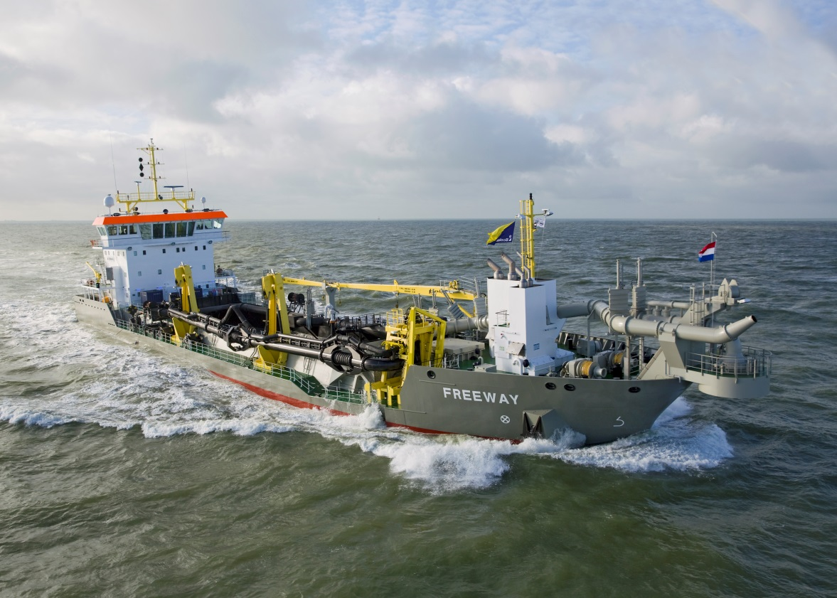
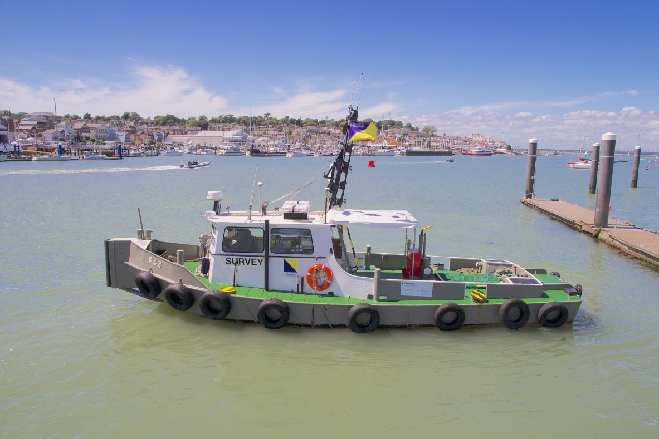
Plates 1 & 2 Typical trailer suction hopper dredger and survey boat operated by Boskalis

